**Common Intents in Android**

**Group members:**

|  |  |  |
| --- | --- | --- |
| **Student ID** | **Student name** | **Intents** |
| 21125080 | Quan Phú Long | 1, 2, 3 |
| 21125045 | Hứa Trường Khả | 4, 5, 6 |
| 21125053 | Thi Hồng Nhựt | 7, 8, 9 |
| 21125145 | Vương Quang Việt Tùng | 10, 11, 12 |

First put the permission to the AndroidManifest file, in my app there are three permissions that the app needs, so I've put:

- ***READ_CONTACTS*** for the selectContact Intent

- ***CALL_PHONE*** to call that contact and

- ***READ_EXTERNAL_STOREAGE*** to access the gallery

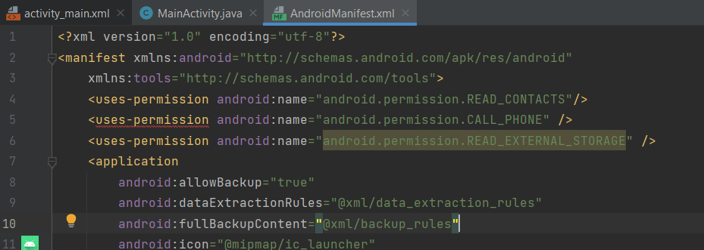

**1. Select a Contact and Call:**

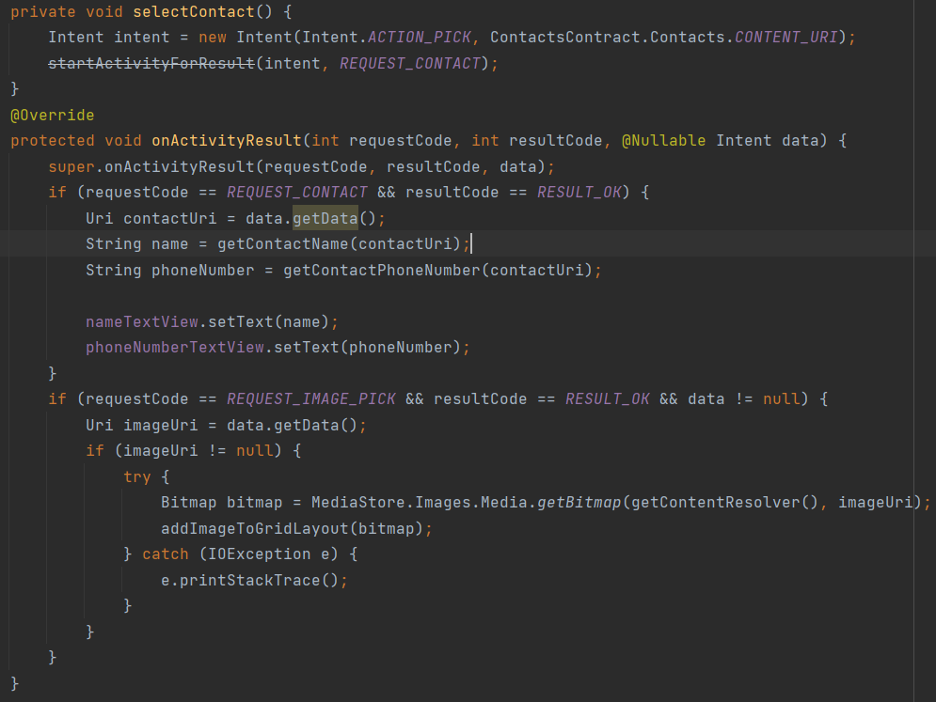

The selectContact function will ask the user to select a contact. And make sure to override the onAvtivityResult function like on the common intent android guide. After picking the contact, it will call that person.

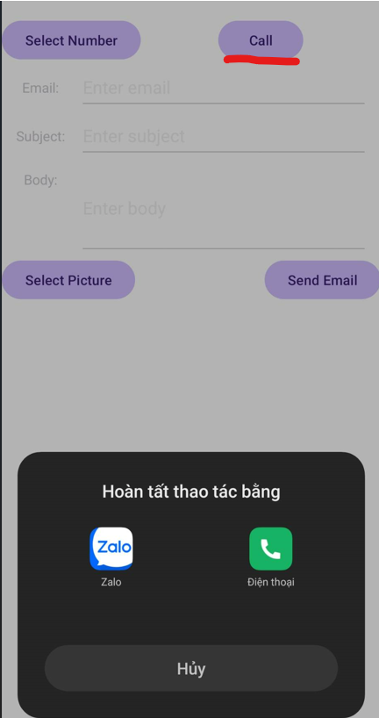

To be able to access contacts and then call phone, the following permisisons must be granted and declared in *AndroidManifest.xml* beforehand:

<uses-permission android:name="android.permission.READ_CONTACTS" />

<uses-permission android:name="android.permission.CALL_PHONE" />

**2. Send email:**

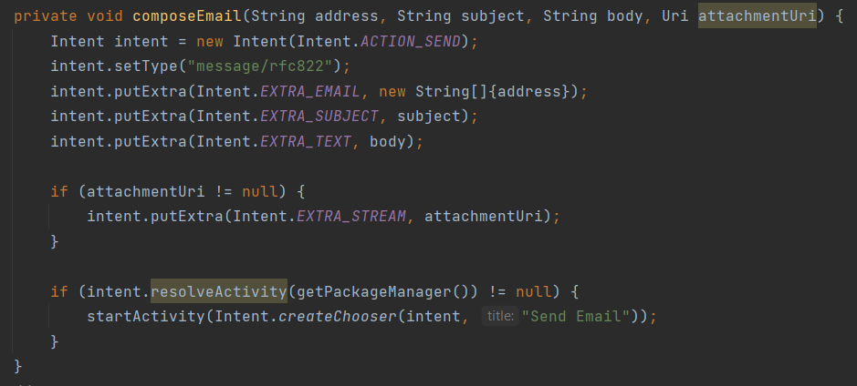

The application does support the ability to send email to a specified recipient. It will use the account from chosen Mail app (such as Gmail) to complete the task. The ability to send attachment is another feature of this intent, allowing the sender to add an attachment to an email.

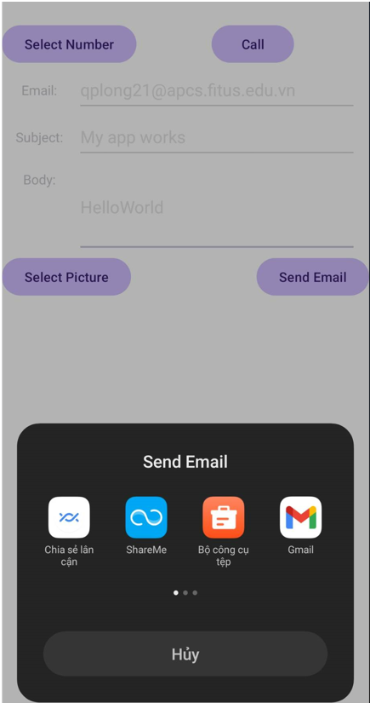 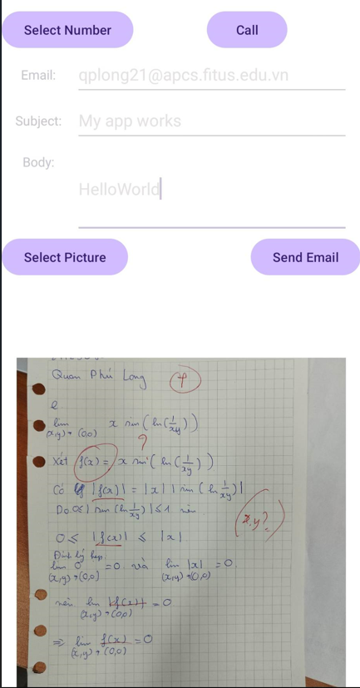

**3. Pick image from Gallery:**

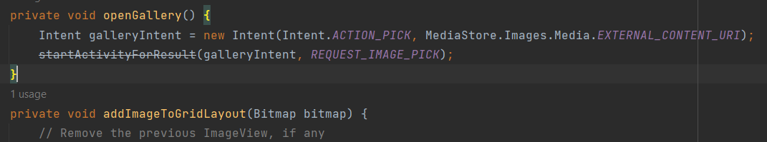



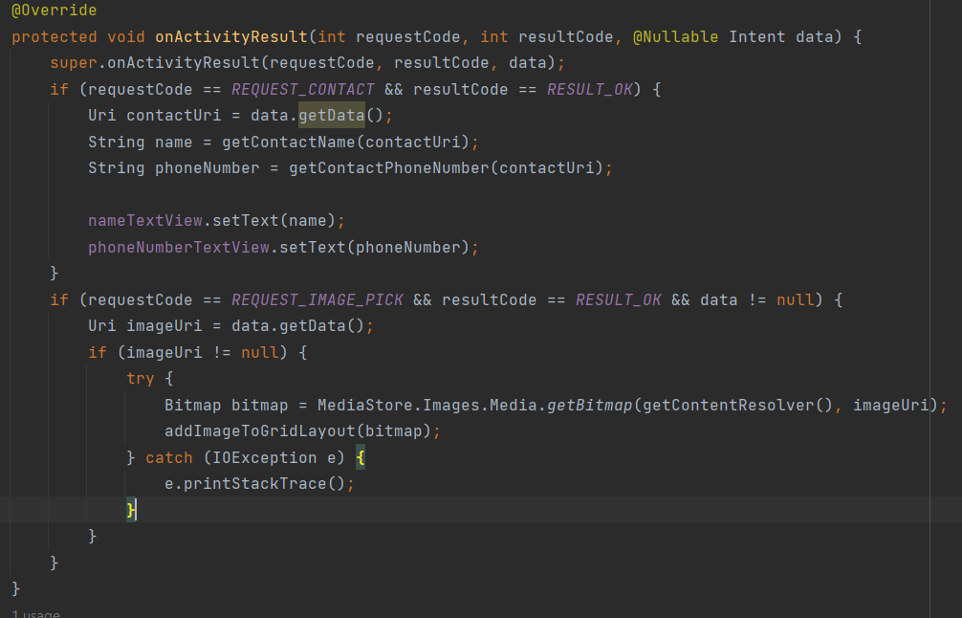

And these are some pictures about my app

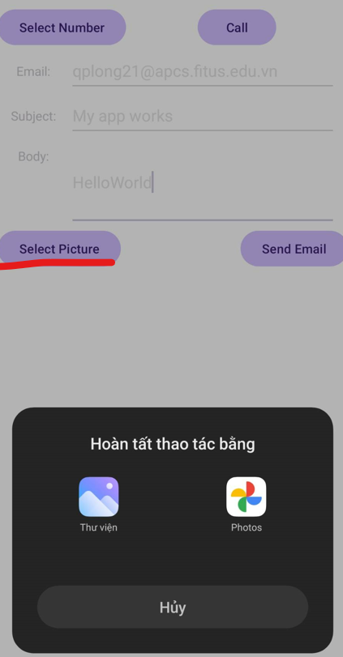

The application must have the required permisison of *reading external storage* in order to proceed with accessing photos and videos from the Gallery:

<uses-permission android:name="android.permission.READ_EXTERNAL_STORAGE" />

**4. Create a timer**

To create a timer, use the **ACTION_SET_TIMER** action.

To specify timer details, use the extras:

**EXTRA_LENGTH:** length of timer in second.

**EXTRA_MESSAGE:** timer name.

**EXTRA_SKIP_UI:** A boolean specifying whether the responding app must skip its UI when setting the timer. If true, the app must bypass any confirmation UI and start the specified timer.

The following permission must be declared in the *AndroidManifest.xml* file to be able to invoke the task of setting alarm:

<uses-permission android:name="com.android.alarm.permission.SET_ALARM"/>

**Example:**

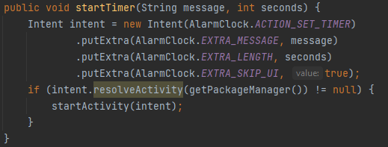

**5. Create a calendar event:**

To add a new event to the user's calendar, use the **ACTION_INSERT** action.

To specify timer details, use the extras:

**EXTRA_EVENT_ALL_DAY:** boolean specifying whether this is an all-day event.

**EXTRA_EVENT_BEGIN_TIME:** start time of the event (milliseconds since epoch)

**EXTRA_EVENT_END_TIME:** end time of the event (milliseconds since epoch)

**TITLE:** event title

**DESCRIPTION:**  event discription

**EVENT_LOCATION:** event location

**EXTRA_EMAIL:** a comma-separated list of email addresses that specify the invitees.

**Example:**

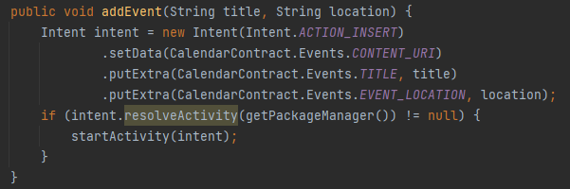

**6. Open camera:**

To open a camera app in ***image*** mode, use the **INTENT_ACTION_STILL_IMAGE_CAMERA** action.

**Example:**

Intent intent = new Intent(MediaStore.*ACTION_IMAGE_CAPTURE*);  
intent.putExtra(MediaStore.*EXTRA_OUTPUT*,  
 Uri.*withAppendedPath*(locationForPhotos, targetFilename));

The application will start the camera app and allow user to capture using this intent. Another mode from the intent is **INTENT_ACTION_VIDEO_CAMERA**, in which it will initiate a video recording mode.

Intent intent = new Intent(MediaStore.*INTENT_ACTION_VIDEO_CAMERA*);

Android development also supports the developer to program how a program should function after taking a picture. It takes data from the intent in the below *Override* function:

@Override  
protected void onActivityResult(int requestCode, int resultCode, Intent data) {  
 if (requestCode == 1 && resultCode == *RESULT_OK*) {

}  
}

**7. Load a web URL**

An Android application allows users to open a web browser with its URL. This is the syntax that we need to apply this intent.

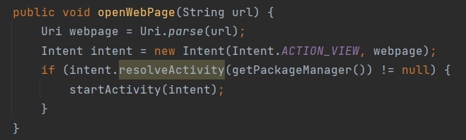

In the file AndroidManifest.xml, we also need to declare the following intent filter.

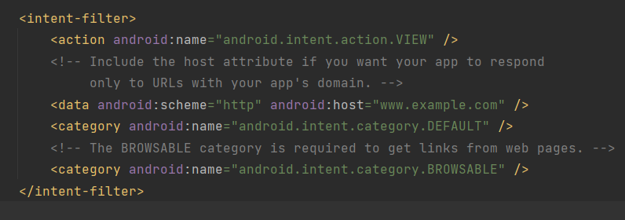

To implement this activity as an application on Android Studio, we need to implement an edit text and a button. The edit text is used to get the URL of the web browser from users. The button is used to trigger the activity of getting data from the edit text and open the web page with that URL.

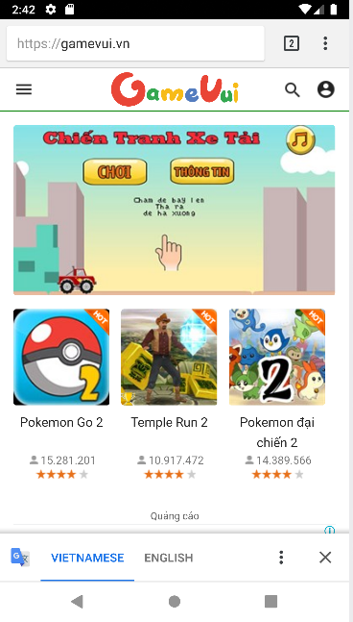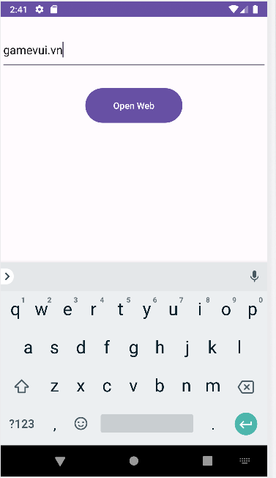

**8. Maps: show a location on a map**

An Android application allows users to input a location in the form of (latitude, longitude) or name. Then, the application will show that location on the map in the map application on the phone. This is the syntax that we need to apply to that activity.

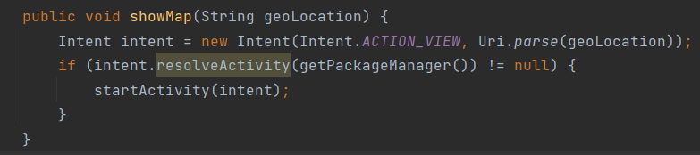

In the file AndroidManifest.xml, we also need to declare the following intent filter.

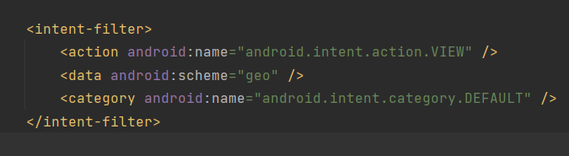

To implement the activity as an application in Android Studio, we can choose whether user want to input the name of locations or the latitude and longitude of them. In both cases, we need to convert the information that users input into a form that is suitable for the intent.





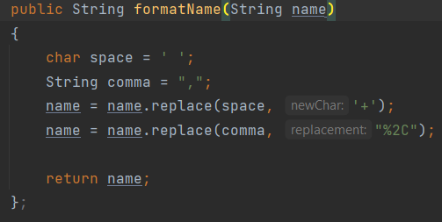

We allow users to choose the mode of information that they want to input. Then, they can input the location information and press “Locate” button to find the location.

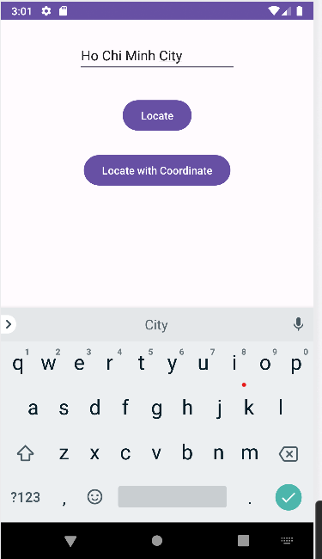 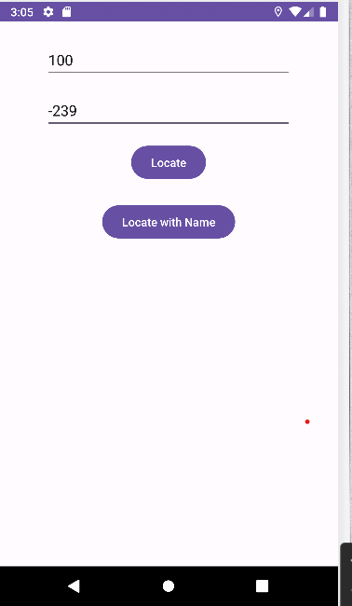

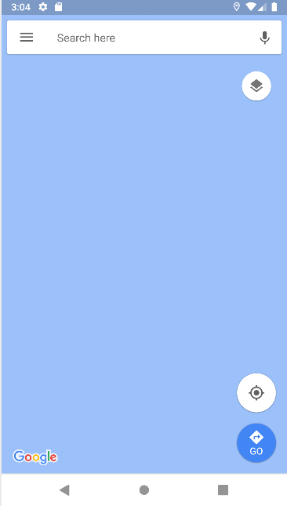

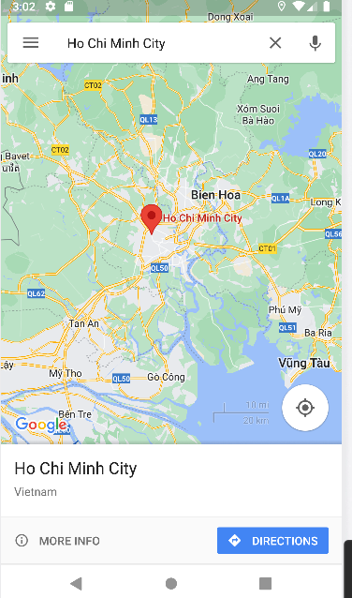

**9. Play a media file**

An Android application allows users to play a media file with the input artists, genres, titles, playlists, albums information of the song. This is the syntax that we need to run the application to play a song with all these attributes.

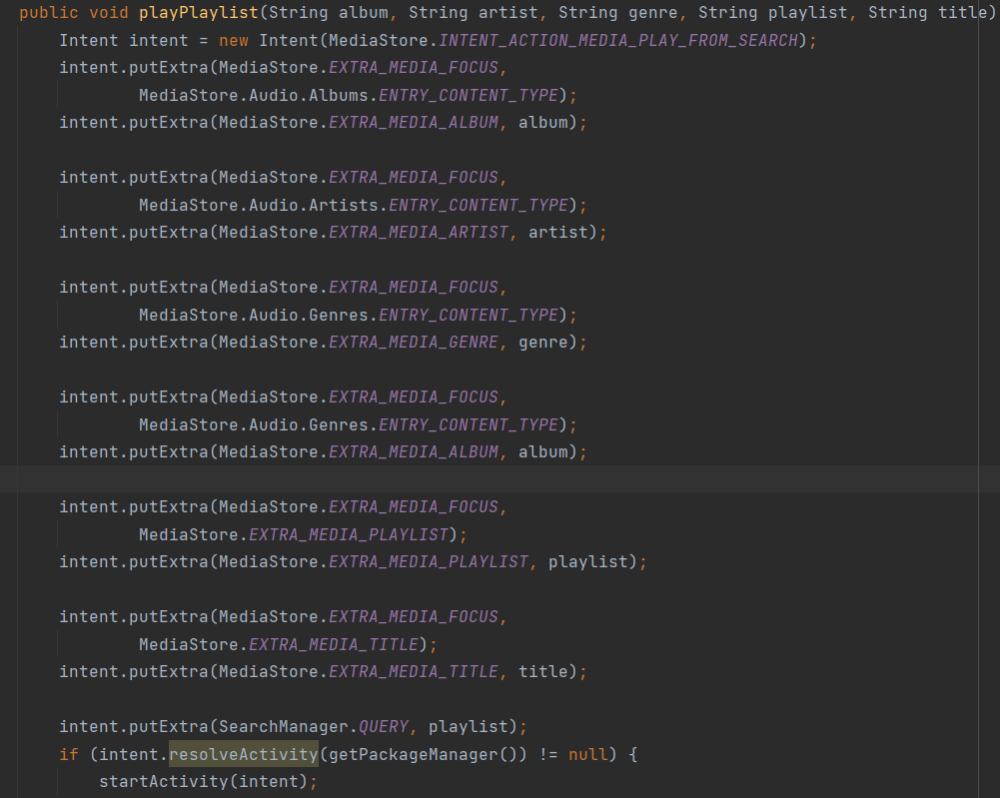

In the file AndroidManifest.xml, we also need to declare the following intent filter.

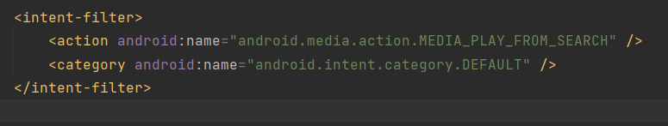

To implement the activity, we need to have 5 edit texts to get the information from the user and a button to trigger the play activity. It will ask the user to pick a music app (for example: Spotify, Apple Music, YouTube Music) and play the corresponding music from the data of the input intent.

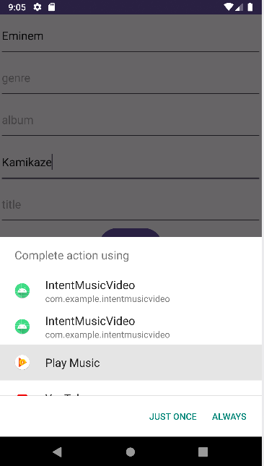 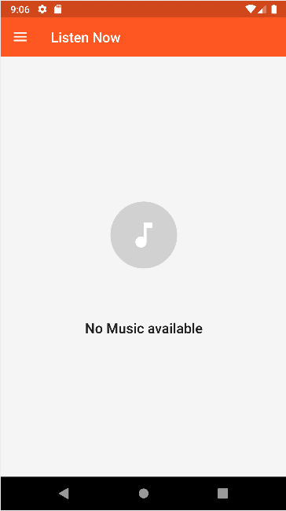

In this case, since there is no music media file available in the mobile app, the application just moves to the music playing application.

Intent intent = new Intent(MediaStore.*INTENT_ACTION_MEDIA_PLAY_FROM_SEARCH*);  
intent.putExtra(MediaStore.*EXTRA_MEDIA_FOCUS*,  
 MediaStore.Audio.Albums.*ENTRY_CONTENT_TYPE*);  
intent.putExtra(MediaStore.*EXTRA_MEDIA_ARTIST*, "Eminem");  
intent.putExtra(MediaStore.*EXTRA_MEDIA_ALBUM*, "Kamikaze");  
intent.putExtra(SearchManager.*QUERY*, "Kamikaze");  
}

The above example will play the album **Kamikaze** by American rapper **Eminem** in a chosen music app. The ***SearchManager.QUERY*** feature is **required** to proceed with the searching and the programmer should specify a search term closely related to the *SONG, ARTIST, ALBUM,* and *GENRE* features to give out the best result.

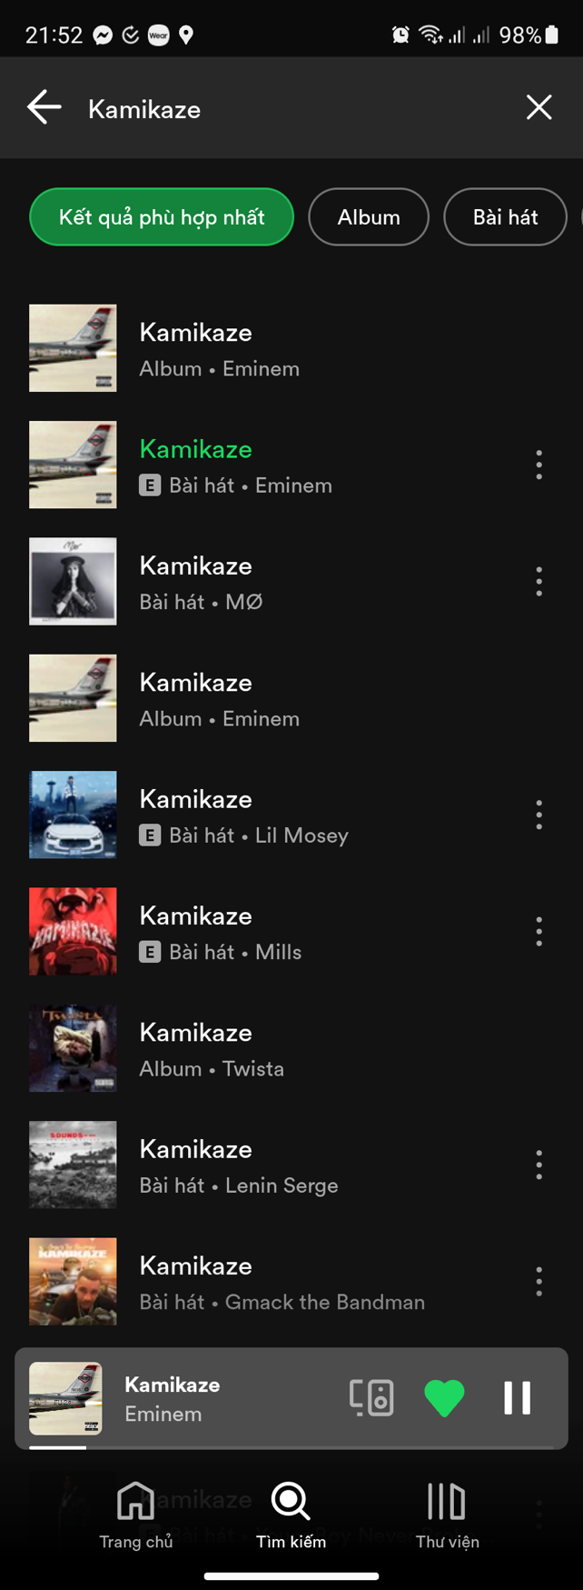

**10. Send SMS message:**

An Android application can direct user to choose which app to send SMS message (with attachment if needed). Here is a code snippet that can achieve this:

public static Intent sendMessage(String content) {  
 Intent intent = new Intent(Intent.*ACTION_SENDTO*);  
 intent.setData(Uri.*parse*("smsto:"));   
 intent.putExtra("sms_body", content);  
 return intent;  
}

The ***setData*** configures the data scheme for SMS messaging (*smsto*). It will use the default messaging app on an Android phone (usually Google Messages on newer Android phones) or ask the user to pick one if there are multiple on the device. We use ***putExtra*** to add the content to the extra name of *sms_body* to declare the body of the message.

In *AndroidManifest.xml,* we declare the below *<queries>* tag to declare which outside application that the our application can work with:

<queries>  
<intent>  
 <action android:name="android.intent.action.SENDTO" />  
 <data android:scheme="smsto"/>  
</intent>  
</queries>

<uses-permission android:name="android.permission.SEND_SMS" />

This also ensures the intent to work after Android 11.

After starting the activity from the intent, it will open the corresponding messaging app, ask the user to pick recipients, and the user has the last opportunity to modify the content of the message before hitting the Send button.

**11. Call to a specified phone number:**

An Android application can initiate a call to a specified phone number. We can use the **setData** to specify the data scheme (*tel* for plain calling or *voicemail* for voicemailing).

public static Intent call(String phoneNumber) {  
 Intent intent = new Intent(Intent.*ACTION_DIAL*);  
 intent.setData(Uri.*parse*("tel:" + phoneNumber));  
 return intent;  
}

The data URI scheme has the syntax:

**tel / voicemail: *<phone number>***

To execute the intent, the ***CALL_PHONE*** permission must be declared in the *AndroidManifest* file. Therefore we declare the *<queries>* tag and its permisison:

<queries>  
 <intent>  
 <action android:name="android.intent.action.DIAL" />  
 <data android:scheme="tel"/>  
 </intent>  
</queries>

<uses-permission android:name="android.permission.CALL_PHONE" />

After starting the intent, it will open the Phone app of the operating system with the already-filled-in phone number in the dialpad interface. The user can change the phone number or click Call.

**12. Settings**

In practical use, the functionality of an Android application can only be executed after modifying a specific setting of the device (for example: Internet, Bluetooth, etc.). Therefore, Android developing supports a common intent for accessing the *Settings* of the device. Furthermore, the application can open to a specific section of the Settings. Here are some example *Settings ACTIONS:*

|  |  |
| --- | --- |
| ACTION_SETTINGS | General Settings of Android |
| ACTION_WIRELESS_SETTINGS | Wireless connection (Wifi, Bluetooth, 5G, 4G) |
| ACTION_AIRPLANE_MODE_SETTINGS | Airplane mode |
| ACTION_WIFI_SETTINGS | Wifi connection |
| ACTION_BLUETOOTH_SETTINGS | Bluetooth connection |
| ACTION_DATE_SETTINGS | Datetime settings |
| ACTION_DISPLAY_SETTINGS | Display settings |
| ACTION_INPUT_METHOD_SETTINGS | Input method for keyboards settings |

Here is the generalized syntax:

Intent(Settings.*<Action name (from the above table>*);

***Example of Wifi settings***